Step 1: open existing database

2 : create MVC Project

3. Right click on Models Folder 🡺 Add New Item🡺 Data pane 🡺ADO.NET entity data Model🡺

Through server and database name connect with database.

4. All classes will be created according to tables in Models Forlder

5. Right click on Controllers 🡺 Add ne wController🡺 DepartmentsController

6. index Method write below code

using EF_DB_FirstDemo.Models;

namespace EF_DB_FirstDemo.Controllers

{

public class DepartmentController : Controller

{

CDO22DN005Entities entities;

// GET: Department

public DepartmentController()

{

entities = new CDO22DN005Entities();

}

[HttpGet]

public ActionResult Index()

{

entities.Departments.ToList();

return View(entities.Departments.ToList());

}

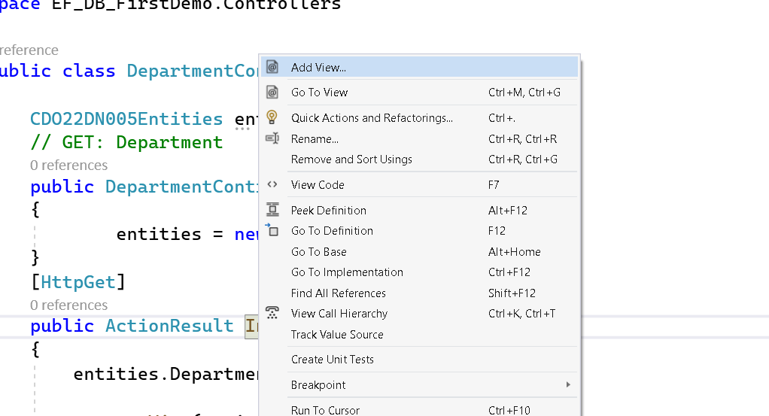

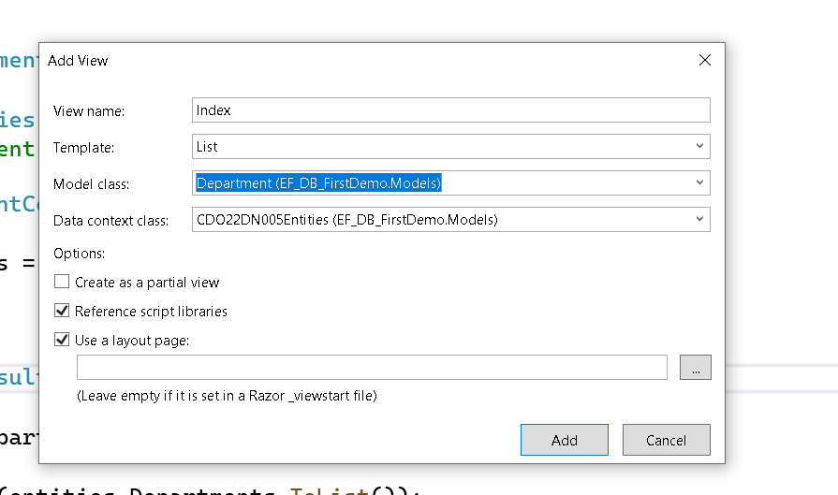

It will create index.cshtml

@model IEnumerable<EF_DB_FirstDemo.Models.Department>

@{

ViewBag.Title = "Index";

}

<h2>Index</h2>

<p>

@Html.ActionLink("Create New", "Create")

</p>

<table class="table">

<tr>

<th>

@Html.DisplayNameFor(model => model.Name)

</th>

<th>

@Html.DisplayNameFor(model => model.Location)

</th>

<th></th>

</tr>

@foreach (var item in Model) {

<tr>

<td>

@Html.DisplayFor(modelItem => item.Name)

</td>

<td>

@Html.DisplayFor(modelItem => item.Location)

</td>

<td>

@Html.ActionLink("Edit", "Edit", new { id=item.id }) |

@Html.ActionLink("Details", "Details", new { id=item.id }) |

@Html.ActionLink("Delete", "Delete", new { id=item.id })

</td>

</tr>

}

</table>

Run Application you will be getting the below output.

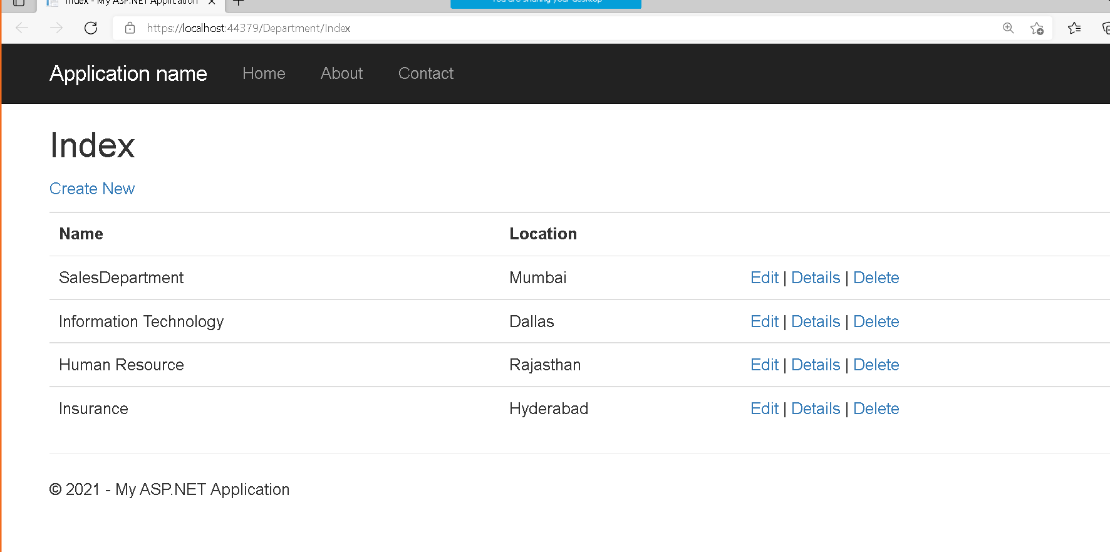

Create

[HttpGet]

public ActionResult Create()

{

return View();

}

[HttpPost]

public ActionResult Create(Department department)

{

if(ModelState.IsValid)

{

entities.Departments.Add(department);

entities.SaveChanges();

}

return RedirectToAction("Index");

}

Right click on create method and Add view

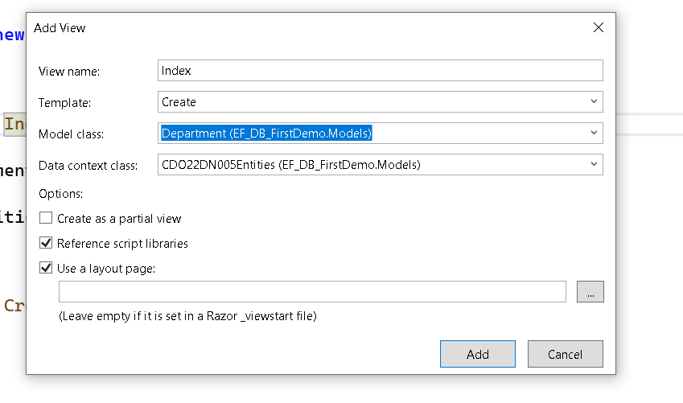

Create.cshtml

@model EF_DB_FirstDemo.Models.Department

@{

ViewBag.Title = "Create";

}

<h2>Create</h2>

@using (Html.BeginForm())

{

@Html.AntiForgeryToken()

<div class="form-horizontal">

<h4>Department</h4>

<hr />

@Html.ValidationSummary(true, "", new { @class = "text-danger" })

<div class="form-group">

@Html.LabelFor(model => model.Name, htmlAttributes: new { @class = "control-label col-md-2" })

<div class="col-md-10">

@Html.EditorFor(model => model.Name, new { htmlAttributes = new { @class = "form-control" } })

@Html.ValidationMessageFor(model => model.Name, "", new { @class = "text-danger" })

</div>

</div>

<div class="form-group">

@Html.LabelFor(model => model.Location, htmlAttributes: new { @class = "control-label col-md-2" })

<div class="col-md-10">

@Html.EditorFor(model => model.Location, new { htmlAttributes = new { @class = "form-control" } })

@Html.ValidationMessageFor(model => model.Location, "", new { @class = "text-danger" })

</div>

</div>

<div class="form-group">

<div class="col-md-offset-2 col-md-10">

<input type="submit" value="Create" class="btn btn-default" />

</div>

</div>

</div>

}

<div>

@Html.ActionLink("Back to List", "Index")

</div>

@section Scripts {

@Scripts.Render("~/bundles/jqueryval")

}